**ASSIGNMENT – 1**

**Q1- What do you understand by the robotic system? What are the components of robots?**

A robotic system is a mechanical device that is designed to perform tasks automatically or with little human intervention. It is typically composed of several components, such as sensors, actuators, controllers, and software, that work together to perform a specific function. Robotic systems are widely used in various industries, such as manufacturing, healthcare, transportation, and entertainment, to perform tasks that are repetitive, dangerous, or difficult for humans to perform. These systems can be programmed to perform a wide range of tasks, from simple movements to complex decision-making processes, and are becoming increasingly advanced and sophisticated with the advancement of technology.

The components of robots are:

**1. Manipulator or the rover:** Main body of the robot which consists of the links, the joints, and other structural elements of the robot. Without other elements, the manipulator alone is not a robot.

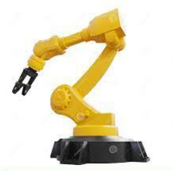 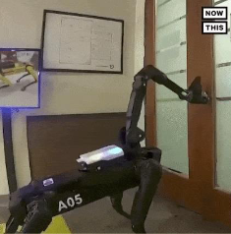

**2. End Effector:** The part is connected to the last joint (hand) of a manipulator that generally handles objects, makes connections toother machines, or performs the required tasks. Robot manufacturer usually supply a simple gripper. Generally, the hand of a robot has provisions for connecting specialty end effectors specifically designed for a purpose, e.g., a welding torch, a paint spray gun, a glue laying device, or a parts handler, etc.

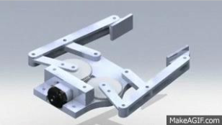 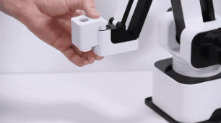

**3. Actuators:** These are the “muscles” of the manipulators. The controller sends signals to the actuators, which, in turn, move the robot joints and links. Common types are servomotors, step per motors, pneumatic actuators, and hydraulic actuators.

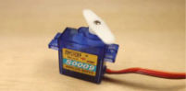 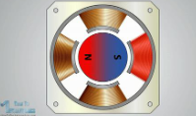 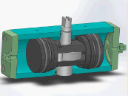

**4. Sensors:** These are used to collect information about the internal state of the robot or to communicate with the outside environment. The robot controller needs to know the location of each link of the robot in order to know the robot’s configuration. Sensors integrated into the robot send information about each joint or link to the controller. Robots are also equipped with external sensory devices such as a vision system, touch and tactile sensors, speech synthesizer, etc.

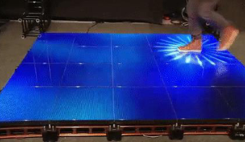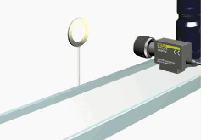

**5. Controllers**: The controller is similar to our cerebellum; it controls our motions. The controller receives data from the computer, controls the motions of the actuators, and coordinates the motions with the sensory feedback information. In more sophisticated robots, the velocity and the force exerted by the robot are also controlled by the controller.

**6. Processor:** The processor is the brain of the robot. It calculates the motions of the robot’s joints, determines how much and how fast each joint must move to achieve the desired location and speeds, and oversees the coordinated actions of the controller and the sensors. It is generally a computer, dedicated to this purpose. It requires an operating system, programs, peripheral equipment like a monitor, and has same limitations and capabilities.

**7. Software:** Three groups of software programs are used in a robot. One is the operating system that operates the processor. The second is the robotic software that calculates the necessary motions of each joint based on the kinematic equations of the robot. The third group is the collection of application-oriented routines and programs developed to use the robot or its peripherals for specific tasks such as assembly, machine loading, material handling, and vision routines.

**Q2- Explain the sensor used and their work for the robotic system?**

**ANS:**

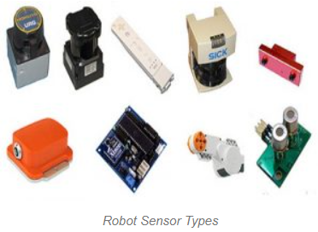

Sensors are essential components of robotic systems, as they allow the robot to perceive its environment and interact with it in a controlled manner. Here are some commonly used sensors in robotics and how they work:

Infrared (IR) Sensors: These sensors emit and detect infrared radiation. They can be used for obstacle detection, line following, and proximity sensing.

Ultrasonic Sensors: Ultrasonic sensors use high-frequency sound waves to detect objects and measure distances. They are commonly used in robotics for object avoidance and localization.

Light Sensors: Light sensors detect light intensity and can be used for a variety of applications, such as line following and detecting changes in ambient light levels.

Touch Sensors: Touch sensors detect physical contact with an object and are commonly used for gripper control and collision detection.

Camera Sensors: Cameras capture visual information from the robot's environment and can be used for tasks such as object recognition, localization, and mapping.

Force Sensors: Force sensors measure the amount of force being applied to a surface and can be used for tasks such as force control and tactile sensing.

Gyroscopes and Accelerometers: These sensors measure the robot's orientation and motion, respectively, and can be used for tasks such as stabilization and motion control.

**Q3- What are the application areas of robot manipulators? Explain in detail. (Main Focus on your domain)**

**ANS:**

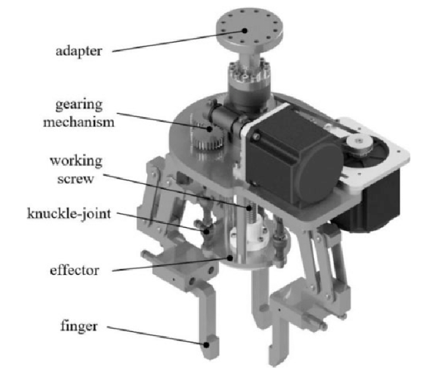

Robot manipulators are a type of robotic arm that can be programmed to perform a wide range of tasks in various application areas. As an AI language model, my domain expertise covers a wide range of topics, so I will provide a general overview of some of the most common application areas for robot manipulators:

**1. Manufacturing:** Robot manipulators are widely used in manufacturing, particularly in assembly and material handling applications. They can be programmed to perform repetitive tasks with high accuracy and speed, which can improve production efficiency and reduce labour costs.

**2. Welding:** Robot manipulators are commonly used in welding applications, where they can perform precise and consistent welds with minimal human intervention. This is particularly important in industries where the quality and reliability of welds are critical, such as aerospace and automotive.

**3. Packaging and Palletizing:** Robot manipulators can be used in packaging and palletizing applications to handle and manipulate products with varying shapes and sizes. They can be programmed to stack and arrange products efficiently and safely, reducing the risk of damage and improving throughput.

**4. Inspection and Testing:** Robot manipulators can be equipped with sensors and cameras to perform inspections and testing on products and materials. They can be programmed to detect defects and anomalies, reducing the need for human intervention and improving quality control.

**5. Medical:** Robot manipulators are increasingly being used in medical applications, such as surgery and rehabilitation. They can be programmed to perform precise and delicate movements, reducing the risk of human error and improving patient outcomes.

**6. Agriculture:** Robot manipulators are being developed for use in agriculture, where they can perform tasks, such as harvesting and pruning. This can improve productivity and reduce the need for human labour in labour-intensive tasks.

In summary, robot manipulators have a wide range of application areas, including manufacturing, welding, packaging, inspection, medical, and agriculture. Their versatility and ability to perform repetitive tasks with high accuracy and speed make them an attractive option for many industries looking to improve efficiency and reduce labour costs.